

FACULTY OF ENGINEERING, SCIENCE AND TECHNOLOGY

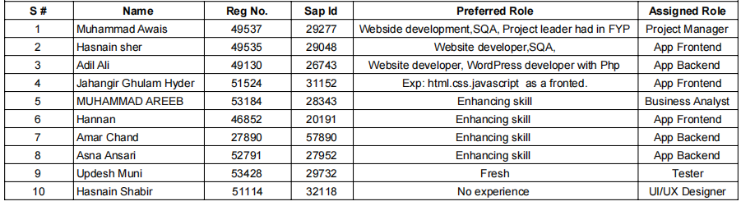DEPARTMENT OF COMPUTER SCIENCE

**ROJECT:**

**Shopkeeper Inventory and POS App**

**COORDINATOR NAME:**

**Daniyal Nawaz**

**Jan/26/ 2024**

**Business Analytic**

**App Name: -**

* Shopkeeper Inventory and POS App

**User Experience:**

* Design an intuitive and user-friendly interface for shopkeepers and customers.
* Streamline inventory management and point-of-sale processes for a positive user experience.

**Feature Analysis:**

* Comprehensive inventory management tools, including product addition, updates, and deletion.
* Efficient point-of-sale system with support for multiple payment methods.
* Barcode scanning integration for quick product addition.
* Real-time inventory tracking and low-stock notifications.
* User authentication system for secure access.

**Pricing Models:**

* Define a transparent pricing model for the app's usage, potentially based on the scale of the shop or number of transactions.
* Consider offering different pricing tiers or plans to cater to various business sizes.

**Event Coverage:**

* Focus on a wide range of retail businesses, including small shops, boutiques, and larger retail establishments.
* Ensure the app is versatile enough to handle various types of products and industries.

**App Performance:**

* Regularly update the app to improve performance and fix any bugs or issues.
* Optimize for speed and efficiency in both frontend and backend operations.

**Marketing and Promotion:**

* Develop a marketing strategy to promote the app's launch to target shopkeepers.
* Emphasize social media promotion, online advertising, and collaborations with industry influencers.

**Customer Support:**

* Provide customer support through multiple channels, including email, chat, and helpline.
* Establish a comprehensive help center with documentation to assist users with common inquiries.
* Consider offering training sessions or materials for shopkeepers to maximize their use of the app

**User Experience:**

* Design an intuitive and user-friendly interface for both shopkeepers and customers.
* Streamline workflows for inventory management and the point-of-sale process.
* Ensure a responsive and visually appealing design.

**Feature Analysis:**

* **Inventory Management:**
  + - Add, update, and delete products easily.
    - Real-time inventory tracking and notifications for low stock.
    - Barcode scanning for quick product addition.
* **Point-of-Sale System:**
  + - Efficient checkout process supporting multiple payment methods.
    - Receipt generation for completed transactions.
* **User Authentication and Security**:
  + - Secure access through user authentication.
    - Encryption and data security measures.
* **Customization Options:**
  + - Settings for tax rates, currency, and other preferences.
* **Reporting and Analytics:**
  + - Basic sales analytics and reporting features.
* **Offline Mode:**
  + - Basic functionality accessible even without an internet connection.

**Pricing Models:**

* + Transparent pricing based on the scale of the shop or number of transactions.
  + Consider different pricing tiers to cater to various business sizes.
  + Subscription-based or one-time purchase models.

**Event Coverage:**

* + Tailored for various retail businesses, including small shops, boutiques, and larger retail establishments.
  + Versatility to handle different types of products and industries.

**App Performance:**

* + Regular updates for performance improvements and bug fixes.
  + Optimize speed and efficiency in both frontend and backend operations.
  + Ensure a seamless and responsive user experience.

**Marketing and Promotion:**

* + Develop a targeted marketing strategy for the app's launch.
  + Leverage social media promotion, online advertising, and industry partnerships.
  + Collaborate with influencers or thought leaders in the retail space.

**Customer Support:**

* + Provide multi-channel customer support (email, chat, helpline).
  + Establish a comprehensive help center with documentation.
  + Consider offering training sessions or materials to assist shopkeepers in using the app effectively.

End!